L&NER Escort Vehicle Operator Competency Training questionnaire
Rail Marshal’s Name |  |  |  | Test Date
Address
Part A  Controls:  Name the Rail tractor controls next to their correct numbers. | 3 |  |  | 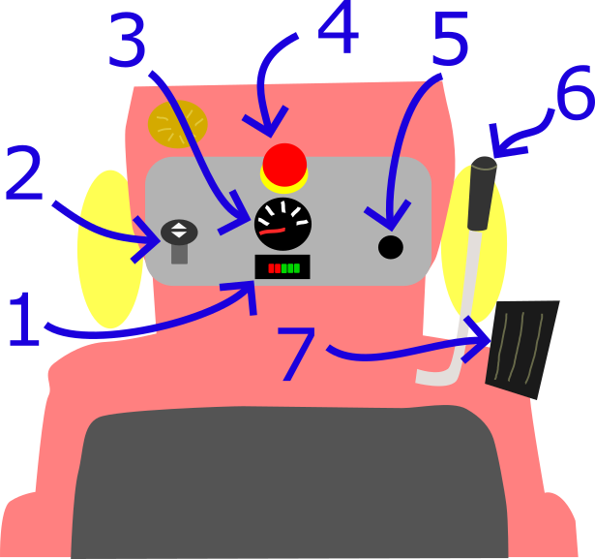
 | 1
 | 5
 | 2
 | 4
 | 6
 | 7
Part B  Daily Checklist:  List the eight items on the Daily Check list | 1? |  | 5?
 | 2? |  | 6?
 | 3? |  | 7?
 | 4? |  | 8?
 | Who do you contact in any emergencies?
Part C  Practical Demonstration | Marshal carries out all pre-departure inspections |  |  |  | Yes/No
Part C  Practical Demonstration | Marshal demonstrates good speed control of rail tractor, especially when “bumping” up to pedal riders to provide assistance. |  |  |  | Yes/No
Part C  Practical Demonstration | Marshall demonstrates sound understanding of braking performance of rail tractor. |  |  |  | Yes/No
Part C  Practical Demonstration | Marshall understands and demonstrates correct manual handling techniques when turning tractor |  |  |  | Yes/No
 | Result | Comments |  |  | Assessor (Signature)
Part A:  Controls | Pass
Part A:  Controls | Re-test
Part B:  Daily Checklist | Pass
Part B:  Daily Checklist | Re-test
Part C:  Practical Demonstration | Pass
Part C:  Practical Demonstration | Re-test

